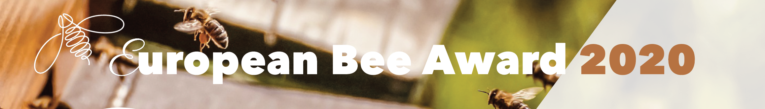
APPLICATION FORM
NAME OF THE APPLICATION/PROJECT | click here to enter text
NAME OF THE APPLICANT | click here to enter text
DATE OF SUBMISSION | click here to enter text

In order to be eligible for the European Bee Award, please fill in the three sections of this Application form:

SECTION I. Contact Information
SECTION II. Description of the project
SECTION III. Compulsory Annex
SECTION IV. Optional Annexes

* Winners are expected to take part in the Award Ceremony in Brussels
* Unsuccessful applicants from previous years are welcome to apply again

Send this form + annexes by September 4^{th,} 2020 to one of the following:
By email:
communication@elo.org
Subject: Bee Award Application

or by post:
Athéna Lefebvre
European Landowners’ Organization
Rue de Trèves 67
B – 1040 Brussels

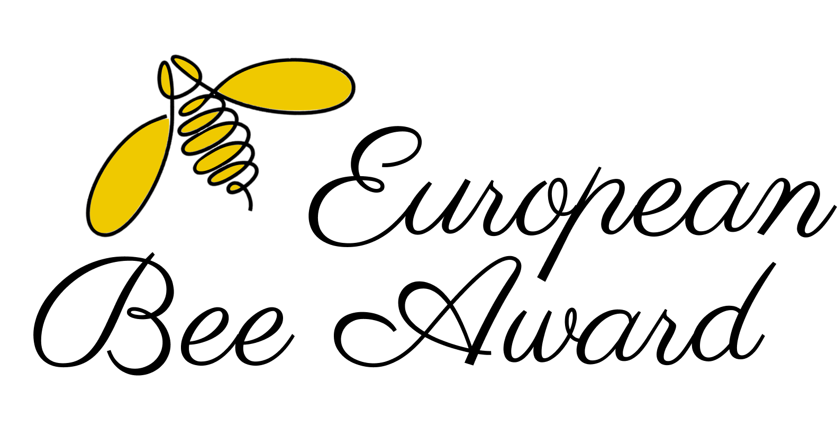
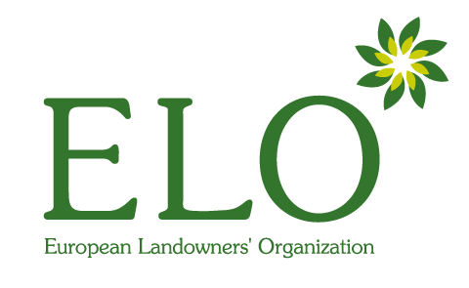
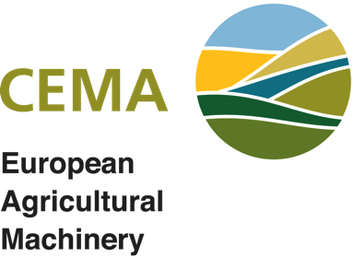
FOREWORD BY THE PRESIDENT OF THE JURY


Bees and other pollinating insects make a critical contribution to crop production and pollination of wild plants. Yet there is concern about declines in these important species accross Europe and elsewhere. With sponsorship from CEMA, the European Landowners’ Organization announces the “European Bee Award”, a prize for a new intervention that promotes the protection of pollinators in the farm environment.

The two prizes will be awarded to a farmer, landowner, research institute, private or public organisation, who possibly in partnership, has developed and implemented an innovative practice that helps to reduce the impact of farming operations on bees and other pollinators. The type of interventions that might be considered include managing part of the farm in ways that benefit pollinators, improving the availability of flowers and other resources that pollinators require and changes to agronomic practices or the use of farm machinery that are pollinator friendly. The independent jury will take a broad view of possible interventions and welcomes novel and innovative ideas. It will consider practices that benefit not only managed honeybee populations but also wild bees and other pollinators. Interventions that measurably improve pollinator wellbeing on all farm types will be considered (for example farms producing any type of food, and both organic and conventional farming systems).
In choosing the winners of the prize, the jury will take into account how much difference the intervention will make, how novel it is, and its scalability – the likelihood that it will be accepted by farmers and implemented widely in Europe. The jury will look for evidence of the effectiveness of the intervention, how practical and compatible it is, and will give extra weight to ideas that also benefit non-pollinator biodiversity or that improve the services that pollinators provide for agriculture.

A Jury special mention has been included since 2017 to recognise small-scale projects and reward excellent but smaller farms and initiatives.

Dr Michael Garratt
President of the Jury

ABOUT THE EUROPEAN BEE AWARD

The European Bee Award was launched in 2014 by the European Landowners’ Organization (www.elo.org) and CEMA, the European Agricultural Machinery Association (www.cema-agri.org) with the aim of celebrating novel innovations that benefit bees, pollinators and biodiversity more generally.
Who can participate? The European Bee Award rewards farmers, landowners, research institutes, academia and private or public organisations who develop outstanding and innovative projects aiming to protect bees or other pollinators and helping to preserve biodiversity.
In 2020, the European Bee Award will reward projects with two main focuses “Land management practices” and “Application of innovative technological solutions”, each with a prize of 4,000 €. The award also comes with a diploma of recognition and the winning project will be promoted through ELO and CEMA communication channels:
- Category 1: Land management practices to protect and enhance pollinators in the farmed environment. The prize will reward developments in farming practices that help create the right living conditions for bees and other pollinators, encouraging their presence in cropped areas while enriching biodiversity in the farmed environment.

- Category 2: Application of innovative technological solutions to reduce farming operations’ impact on pollinators. A special focus will be placed this year on projects that new technologies and new applications of technologies to allow bees and other pollinators to be better protected from the impact of farming operations (for example, application of crop protection products or during harvesting).

- In addition to the above categories, a “Jury special mention” will be awarded by diploma of recognition for an excellent small-scale project, farm or initiative.

An independent jury chaired by Dr Michael Garratt (University of Reading) and including international experts, members of the European Institutions and NGOs will be in charge of assessing which practices and innovative ideas in agriculture most contribute to the maintenance of good pollinator communities in Europe’s farmed landscape.

EXAMPLES THAT MATCH THE AWARD CRITERIA THE JURY WILL WELCOME
- Novel and innovative ideas to protect bees and pollinators
- Projects that are scalable
- Technological solutions that can demonstrate efficacy
- Practices that also benefit non-pollinator biodiversity in the farmed environment
- New crop management practices that benefit both managed honeybee populations and also wild bees and other pollinators
- New ways to manage non-cropped areas that increase the availability of flowers and other resources for pollinators
- Innovation in integrated pest management that use modern technology to reduce negative effects on pollinators
- New farm equipment technologies that reduce the impact of farming operations on honeybees and other pollinators
SECTION I. CONTACT INFORMATION

Applicant
Short Name | click here to enter text
Legal Name | click here to enter text
Legal Status | Public Private Natural person

Legal Address of the Applicant
Street | click here to enter text | Number | click here to enter text
Postcode | click here to enter text
Town / City | click here to enter text
Country | click here to enter text

Contact Person Details
Name | click here to enter text | Function | click here to enter text
Phone | click here to enter text | Fax | click here to enter text
Email | click here to enter text

About the participant Property / Estate / University / Project…
Name | click here to enter text
Address, City, Country | click here to enter text
Phone | click here to enter text | Fax | click here to enter text
Email | click here to enter text | Website | click here to enter text

Characteristics of the Property / Estate (if applicable)
Number of hectares | insert number | Owned | insert number | Rented | insert number
Main crops produced | click here to enter text

Partner’s Information
Fill in this section if your project is in partnership. (Please, duplicate for more than one partner)

PARTNER 1
Name | click here to enter text
Legal Status | Public Private Natural person
Other information about the Partner | click here to enter text

Contact and Legal address of the partner
Contact Person | click here to enter text | Function | click here to enter text
Email | click here to enter text | Phone | click here to enter text
Address, City, Country | click here to enter text

PARTNER 2
Name | click here to enter text
Legal Status | Public Private Natural person
Other information about the Partner | click here to enter text

Contact and Legal address of the partner
Contact Person | click here to enter text | Function | click here to enter text
Email | click here to enter text | Phone | click here to enter text
Address, City, Country | click here to enter text

PARTNER 3
Name | click here to enter text
Legal Status | Public Private Natural person
Other information about the Partner | click here to enter text

Contact and Legal address of the partner
Contact Person | click here to enter text | Function | click here to enter text
Email | click here to enter text | Phone | click here to enter text
Address, City, Country | click here to enter text

SECTION II. DESCRIPTION OF THE PROJECT

MY PROJECT FITS BEST IN THE CATEGORY (Please choose one):

Category 1: Land management practices
Category 2: Application of innovative technological solutions

click here to enter text
SUMMARY OF THE PROJECT (150 words max.)

click here to enter text
OBJECTIVES (500 words max.)

METHODOLOGY (500 words max.)
click here to enter text

RESULTS (1000 words max.)
click here to enter text

OTHER INFORMATION FOR THE JURY (1000 words max.)
click here to enter text

SECTION III. COMPULSORY ANNEXES

In order to be eligible, please attach a short video or presentation showcasing your project. It will be used for communication and promotion of the winning projects and during the Award Ceremony.

Type of document attached | Description of the document
Short video | clik here to enter text
Power Point | clik here to enter text

SECTION IV. OPTIONAL ANNEXES

The Jury will base its decision largely on the material in Section II tough applicants may submit other material that the Jury may have the option of considering.

Type of document attached | Description of the document
Map | clik here to enter text
Pictures | clik here to enter text
Logo | clik here to enter text
Brochure | clik here to enter text
Book | clik here to enter text
Others (specify) | clik here to enter text

* I acknowledge that the pictures and other materials submitted may be used for ELO and CEMA communication purposes.

ACKNOWLEDGEMENT OF RECEIPT

Contact person | click here to enter text
Contact email | click here to enter text
 | Tick the box if you DO NOT want to be featured on the ELO website after the contest as a participant of the Bee Award 2020

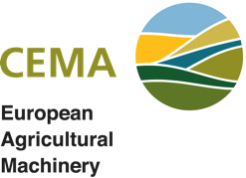
Dear participant,

We thank you for your application and we will acknowledge receipt through your contact email.
The members of the jury will now examine your proposal, and we will announce you the results at the end of the evaluation procedure (end of October). By applying you will automatically be added to the mailing list of ELO. You can unsubscribe at any time at the bottom of the emails.

We wish you the best of luck.
Yours sincerely,

European Bee Award Coordination

